**Topics: Descriptive Statistics and Probability**

1. Look at the data given below. Plot the data, find the outliers and find out $μ, σ, σ^{2}$

|  |  |
| --- | --- |
| **Name of company** | **Measure X** |
| Allied Signal | 24.23% |
| Bankers Trust | 25.53% |
| General Mills | 25.41% |
| ITT Industries | 24.14% |
| J.P.Morgan & Co. | 29.62% |
| Lehman Brothers | 28.25% |
| Marriott | 25.81% |
| MCI | 24.39% |
| Merrill Lynch | 40.26% |
| Microsoft | 32.95% |
| Morgan Stanley | 91.36% |
| Sun Microsystems | 25.99% |
| Travelers | 39.42% |
| US Airways | 26.71% |
| Warner-Lambert | 35.00% |

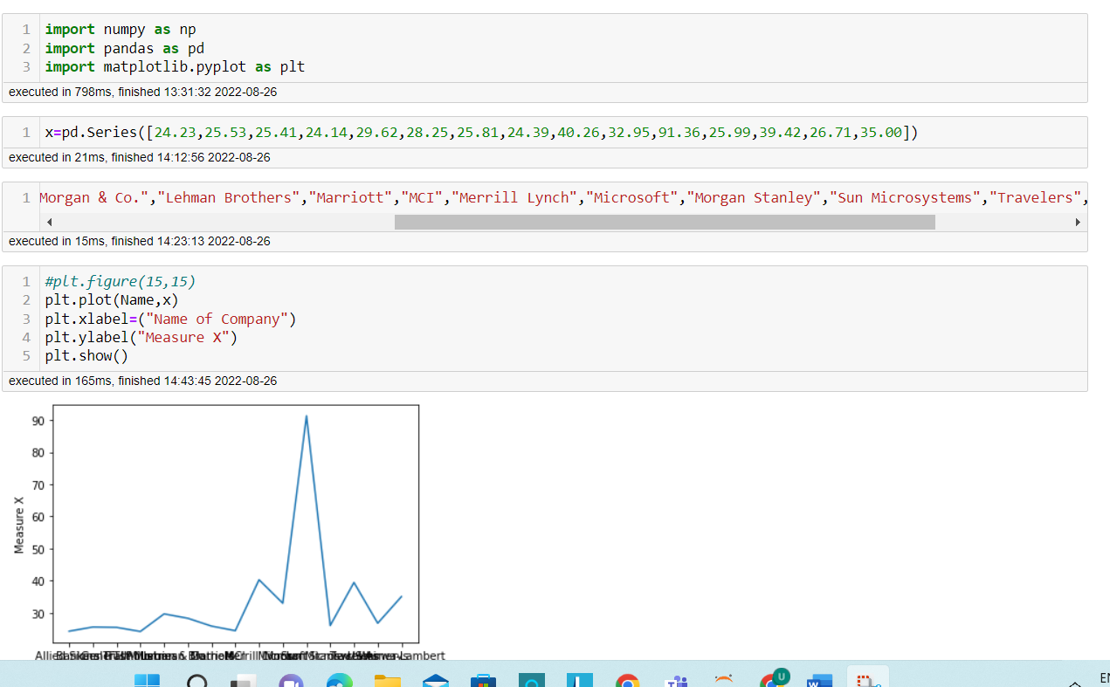

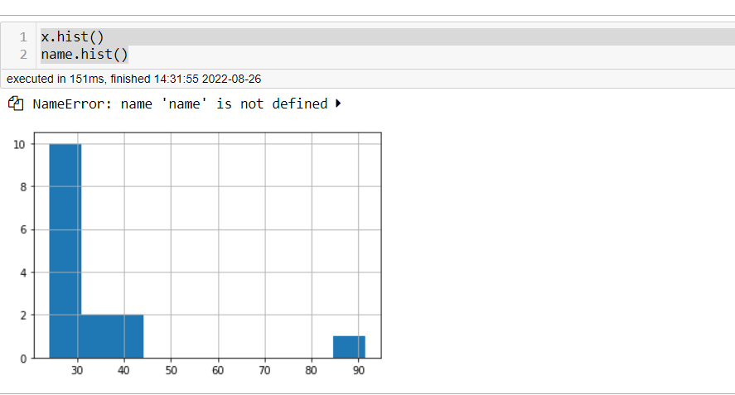

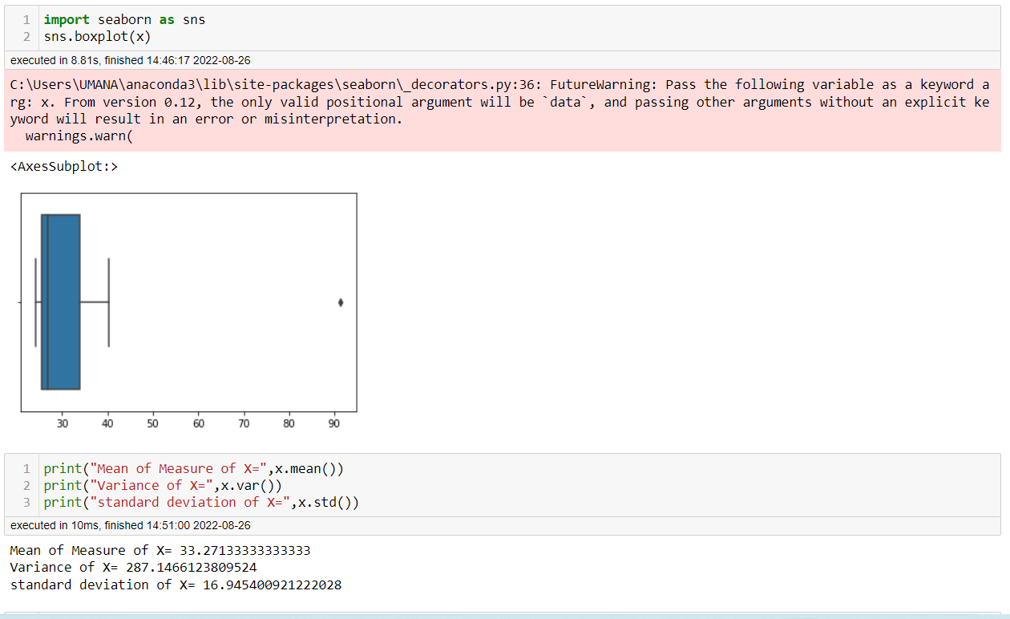



Answer the following three questions based on the box-plot above.

1. What is inter-quartile range of this dataset? (please approximate the numbers) In one line, explain what this value implies.

**The upper Quartile=12**

**The lower quartile-5**

**Inter quartile range=12-5=7**

**That is the median and 50% data is in the range.**

1. What can we say about the skewness of this dataset?

**The data is right skewed**

1. If it was found that the data point with the value 25 is actually 2.5, how would the new box-plot be affected?

**We cannot see outliers.**



Answer the following three questions based on the histogram above.

1. Where would the mode of this dataset lie?

**Mode is between 4 and 8**

1. Comment on the skewness of the dataset.

**The data is right Skewed.**

1. Suppose that the above histogram and the box-plot in question 2 are plotted for the same dataset. Explain how these graphs complement each other in providing information about any dataset.

**Median in boxplot and mode in Histogram.**

**Histogram provides frequency distribution and boxplot provides quartile distribution.**

**In boxplot the whisker length will identify the outliers. In histogram we cannot but we can guess 25 because it has space.**

1. AT&T was running commercials in 1990 aimed at luring back customers who had switched to one of the other long-distance phone service providers. One such commercial shows a businessman trying to reach Phoenix and mistakenly getting Fiji, where a half-naked native on a beach responds incomprehensibly in Polynesian. When asked about this advertisement, AT&T admitted that the portrayed incident did not actually take place but added that this was an enactment of something that “could happen.” Suppose that one in 200 long-distance telephone calls is misdirected. What is the probability that at least one in five attempted telephone calls reaches the wrong number? (Assume independence of attempts.)

**Probability of telephone calls miss directed=1/200=0.005**

**Probability of calls=1-1/200=0.995**

**No. of calls=5**

**P(x) = ⁿCₓpˣqⁿ⁻ˣ**

**at least one in five attempted telephone calls reaches the wrong number=**

**1-5c0(0.005)^0(0.995)^5**

**=1-0.975**

**=0.025**

1. Returns on a certain business venture, to the nearest $1,000, are known to follow the following probability distribution

|  |  |
| --- | --- |
| x | P(x) |
| -2,000 | 0.1 |
| -1,000 | 0.1 |
| 0 | 0.2 |
| 1000 | 0.2 |
| 2000 | 0.3 |
| 3000 | 0.1 |

1. What is the most likely monetary outcome of the business venture?

**Maximum probability=0.3 so the most likely monetary outcome of business venture=2000**

1. Is the venture likely to be successful? Explain

**The venture is likely to be successful. P(x>0) =0.2+0.3+0.1=0.6**

There is 60%chances to be successful.

1. What is the long-term average earning of business ventures of this kind? Explain

**Expected value=sum of E(x)*(p(x)**

**(-2000*0.1)+((-1000*0.1)+(0*0.2)+(1000*0.2)+(2000*0.3)+(3000*0.1)=800**

**Long term average earnings of business venture=800$**

1. What is the good measure of the risk involved in a venture of this kind? Compute this measure

**P(loss)=p(-2000)+p(-1000)=0.1+0.1=0.2**

**So the risk involved in a venture is 20%.**